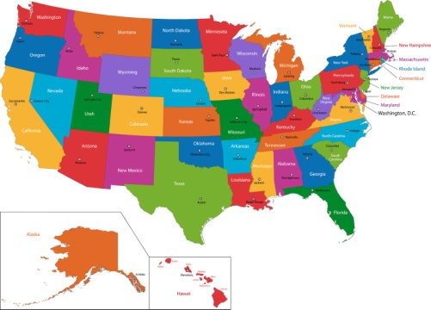
States Challenge!

There is a special challenge your third grader can work for as part of our 50 States unit. The State Superstar Award is given to third graders who memorize the locations of all 50 states on a blank map.

In order to receive the State Superstar Award, students need to be able to correctly place the states on the game found on Miss Coon’s corner on the Social Studies and Science page:

http://misscoonscorner.weebly.com/social-studiesscience.html

Students have been playing various map games at school to become familiar with the locations of the states. However, many students were interested in practicing at home too. Practicing the online game with a labeled map in front of them has helped many students earn the award in the past.

The State Superstar award is completely optional, and it can be earned at any time in the school year, not just during our United States History unit.

When students feel ready to try for the State Superstar Award at school, they just let me know, and I will watch them play the online game to see if they can get 100% with no help.

If you have any questions, feel free to email me at emily.coon@pekin.net or send me a text on the “Remind” app.

Thank you!
-Miss Con

