A Chick Hatches

By Miss Coon

5-11-13

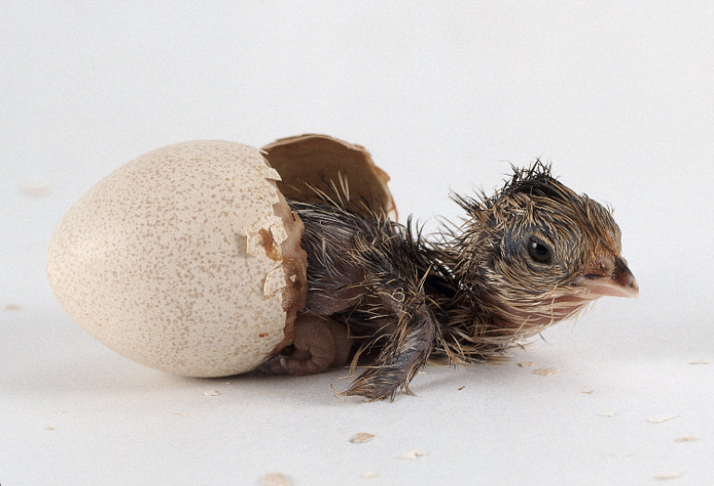

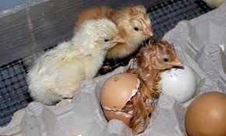

“Peck, peck, peck!” A tiny beak begins to appear and disappear as it works to break open the white prison walls. The hole starts out small and begins to spread across the shell. After a long struggle, an exhausted chick tumbles out wet and weak. After a long nap and a chance to dry off, a small yellow chick picks itself up and begins the hunt for food. In this book, you will join Miss Coon and her class to learn about how to hatch and take care of chicks.

When a chick is about 5 months old, they are an adult chicken. If it is a girl, it is called a hen. If it is a boy, it is called a rooster. To hatch a chick, the rooster fertilizes the egg and the hen lays the eggs. Next, the eggs must be kept warm, so the hen sits on her eggs for 21 days. This is called brooding.
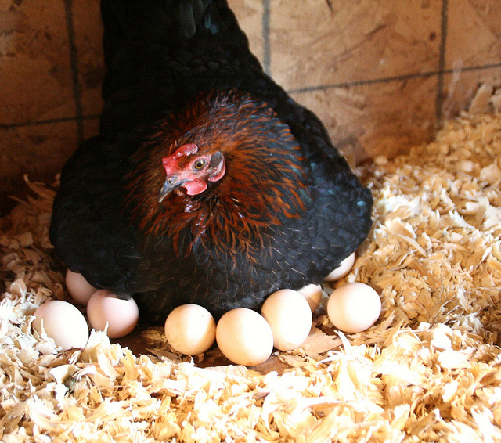

The hen moves the eggs around in the nest to make sure all the eggs stay at that just right temperature.

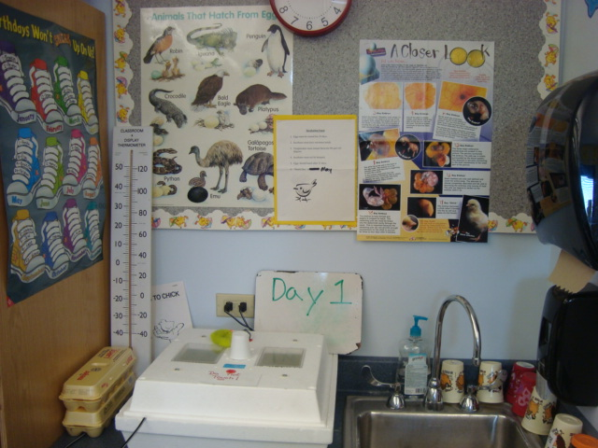
In our classroom, we do not have a hen; instead we have an incubator. This is a white box that has a special heater in it to keep the eggs warm. We have an egg holder that turns the eggs for us just like the hen turns the eggs in the nest.

It is very important for the eggs to stay at a perfect temperature (99 -103 F) so that they grow just right. Everyday, we have to write down the temperature in the classroom and inside the incubator.

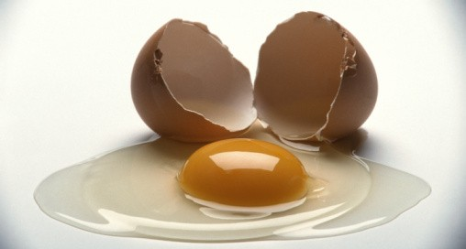

Starting from the outside in, the first part of an egg is the shell. The shell can be white or brown. Even thought they are invisible, eggshells have tiny holes in them so that the growing chick can get oxygen. In the next layer of the shell, there is a membrane called the allantois. When you break open an egg, it is the clear film that is attached to the shell. It is like a balloon layer blown up inside the shell that holds and protects the developing chick. This membrane is important because it keeps any bad thing that might sneak in through the tiny holes away from the chick. It is so amazing that it also carries oxygen to the chick since it can’t breathe on its own yet.

The other two parts of the egg you might already know about: the egg white and the yolk. These actually do not turn into the baby chicken. Instead, these are actually the chick’s food while it is still growing inside the shell. So, what does turn into the baby chick? Well, if you look really closely at the yolk, there is a tiny white spot. If that spot is fertilized, it will have a ring around it. That is the beginning of the chick embryo. The embryo is what the growing chick is called as it develops. Now all these things just don’t float around in the egg, but they are held in place by a rope called the chalazae. This protects the embryo from getting hurt when the egg is being turned or is bumped into another egg on accident.

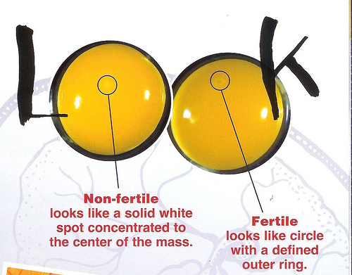

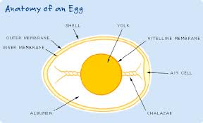

Now that the excitement of the eggs arriving has passed by, we have to wait patiently as we wait for the chicks to grow. Even though it doesn’t seem like much is happening, changes are happening quickly inside the egg.

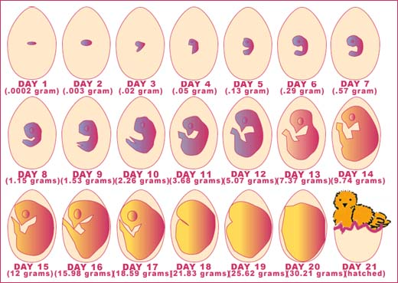

By the end of the first day, the chick’s backbone is already forming. And on day two, the ears, eyes, brain, and circulatory system begin to form. By day 4, its heart is already beating and the allantois is carrying oxygen to the embryo.

On the first day before we put the eggs into the incubator, we put them on the overhead projector and turned the lights out. This made the eggs glow so that we could see the chick growing. This is called candling. Since it was the first day, we did not see anything. We gave each of the eggs a number and made guesses on which eggs we thought would hatch.
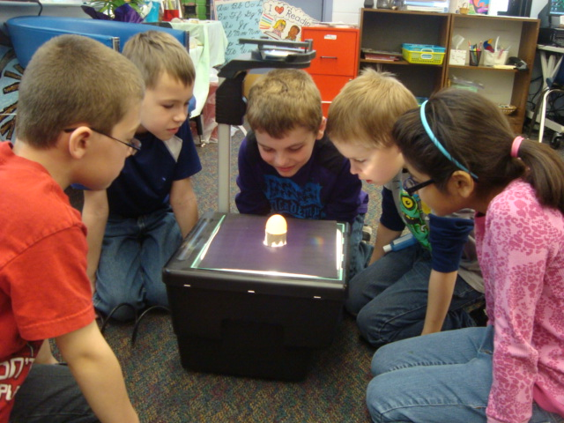

As we waited for the chicks to develop and to hatch, we were able to candle the eggs 3 more times. On day 7 we were able to see a small shadow. Although we couldn’t see it, the chick’s feathers were starting to develop. On day 14, the chicks had grown quite a bit in some of the eggs. They all seemed to be different sizes inside the eggs. The last day we could candle the eggs was on day 17. We were able to see them moving a bit and what we thought were the chick’s feet and wings. The air space was really easy to see. This is where the chick will first begin breathing and using its lungs on day 20 right before it hatches.
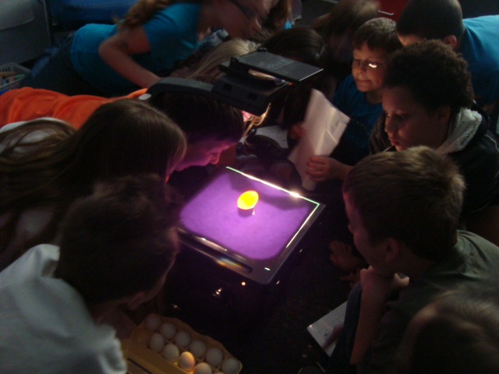
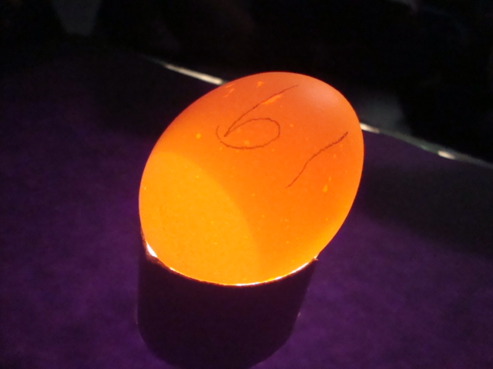

On day 18, the eggs cannot be turned anymore as the chicks prepare to hatch. The hen automatically knows that, but in our classroom, we had to take out the yellow turner and put our eggs back into the incubator. To make sure everything is just right for the chicks, it is also important to add cheesecloth on top of the wire so that when the chicks hatch, they do not get stuck in the wires. We also had to add sponges with more water so that there is a lot of humidity. If there is not enough, the chicks could stick to their eggs and not be able to hatch just right and they could get hurt or die.
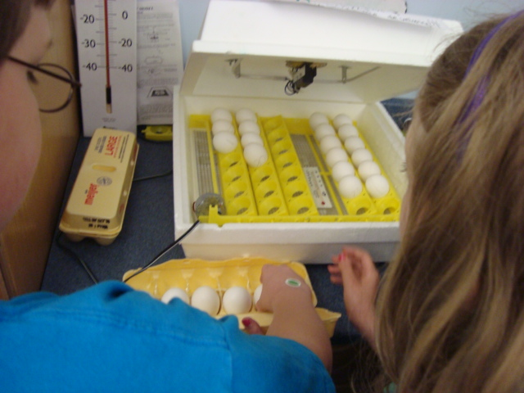
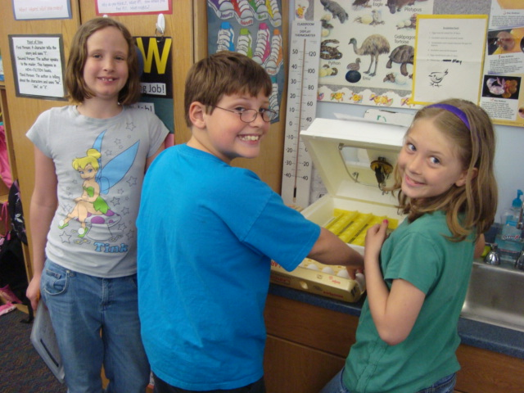

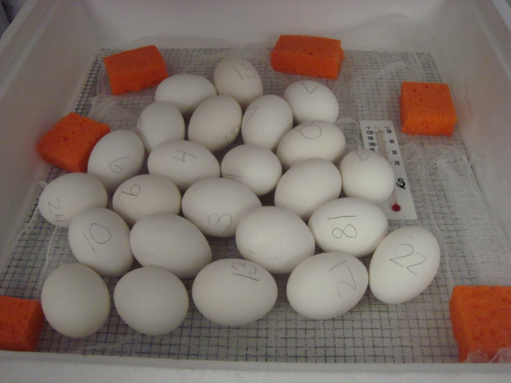

Just like we are preparing for the chicks to hatch, they are also getting ready for the “trip.” They have a lot of hard work to do to get out of the egg. While they are still growing in the egg, on their beak a little sharp point grows like a tooth. This is called an egg tooth. Their egg tooth helps the chicks to peck at the hard shell and break through to freedom. When it pecks, it is called pipping.
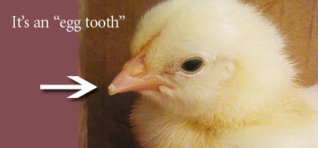

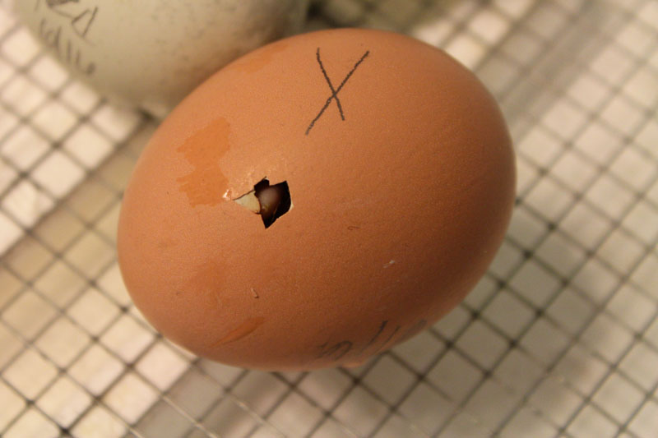

The chicks only need their egg tooth to hatch because after a few days, they loose their tooth since they do not need it any more. Chickens do not have teeth; in fact, they swallow their food whole and there are small pebbles in their digestive tract that help break down the food.

There is a lot of excitement in the air as the students rush into the classroom and make a beeline to the incubator to check on the chickens. They have waited a long 21 days and are excited to see what has happened and to check if their egg has hatched. When the chicks start to hatch, it is important to take out the red vent plugs that are on top of the incubator so the chicks can have fresh air. The chicks do not look yellow and fluffy like all the pictures at Easter time. Instead, they look wet and slimy and they do not move a lot. After a long nap and a bit of time to dry off, they will look much better!
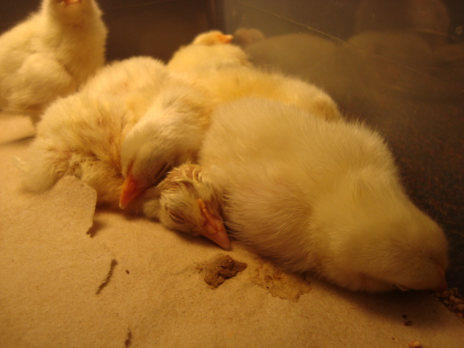

As the chicks dry off and are pecking around for food in the incubator, they can be taken out and put into a box that we have prepared just for them called the brooding box. In the box, there is kitty litter for a bedding, corn feed, and water. When you set up the water container, you need to make sure you put rocks or marbles in the water so that the chicks don’t accidentally fall in and drown. Also, on one side of the box, it is important to put a 70 or 100-watt light bulb so that the chicks can still find a warm place to sleep. As the chicks dry off, we can put them into the box. Any eggs that have not hatched must stay in the incubator until day 23 or 24 in case they are late hatchers.
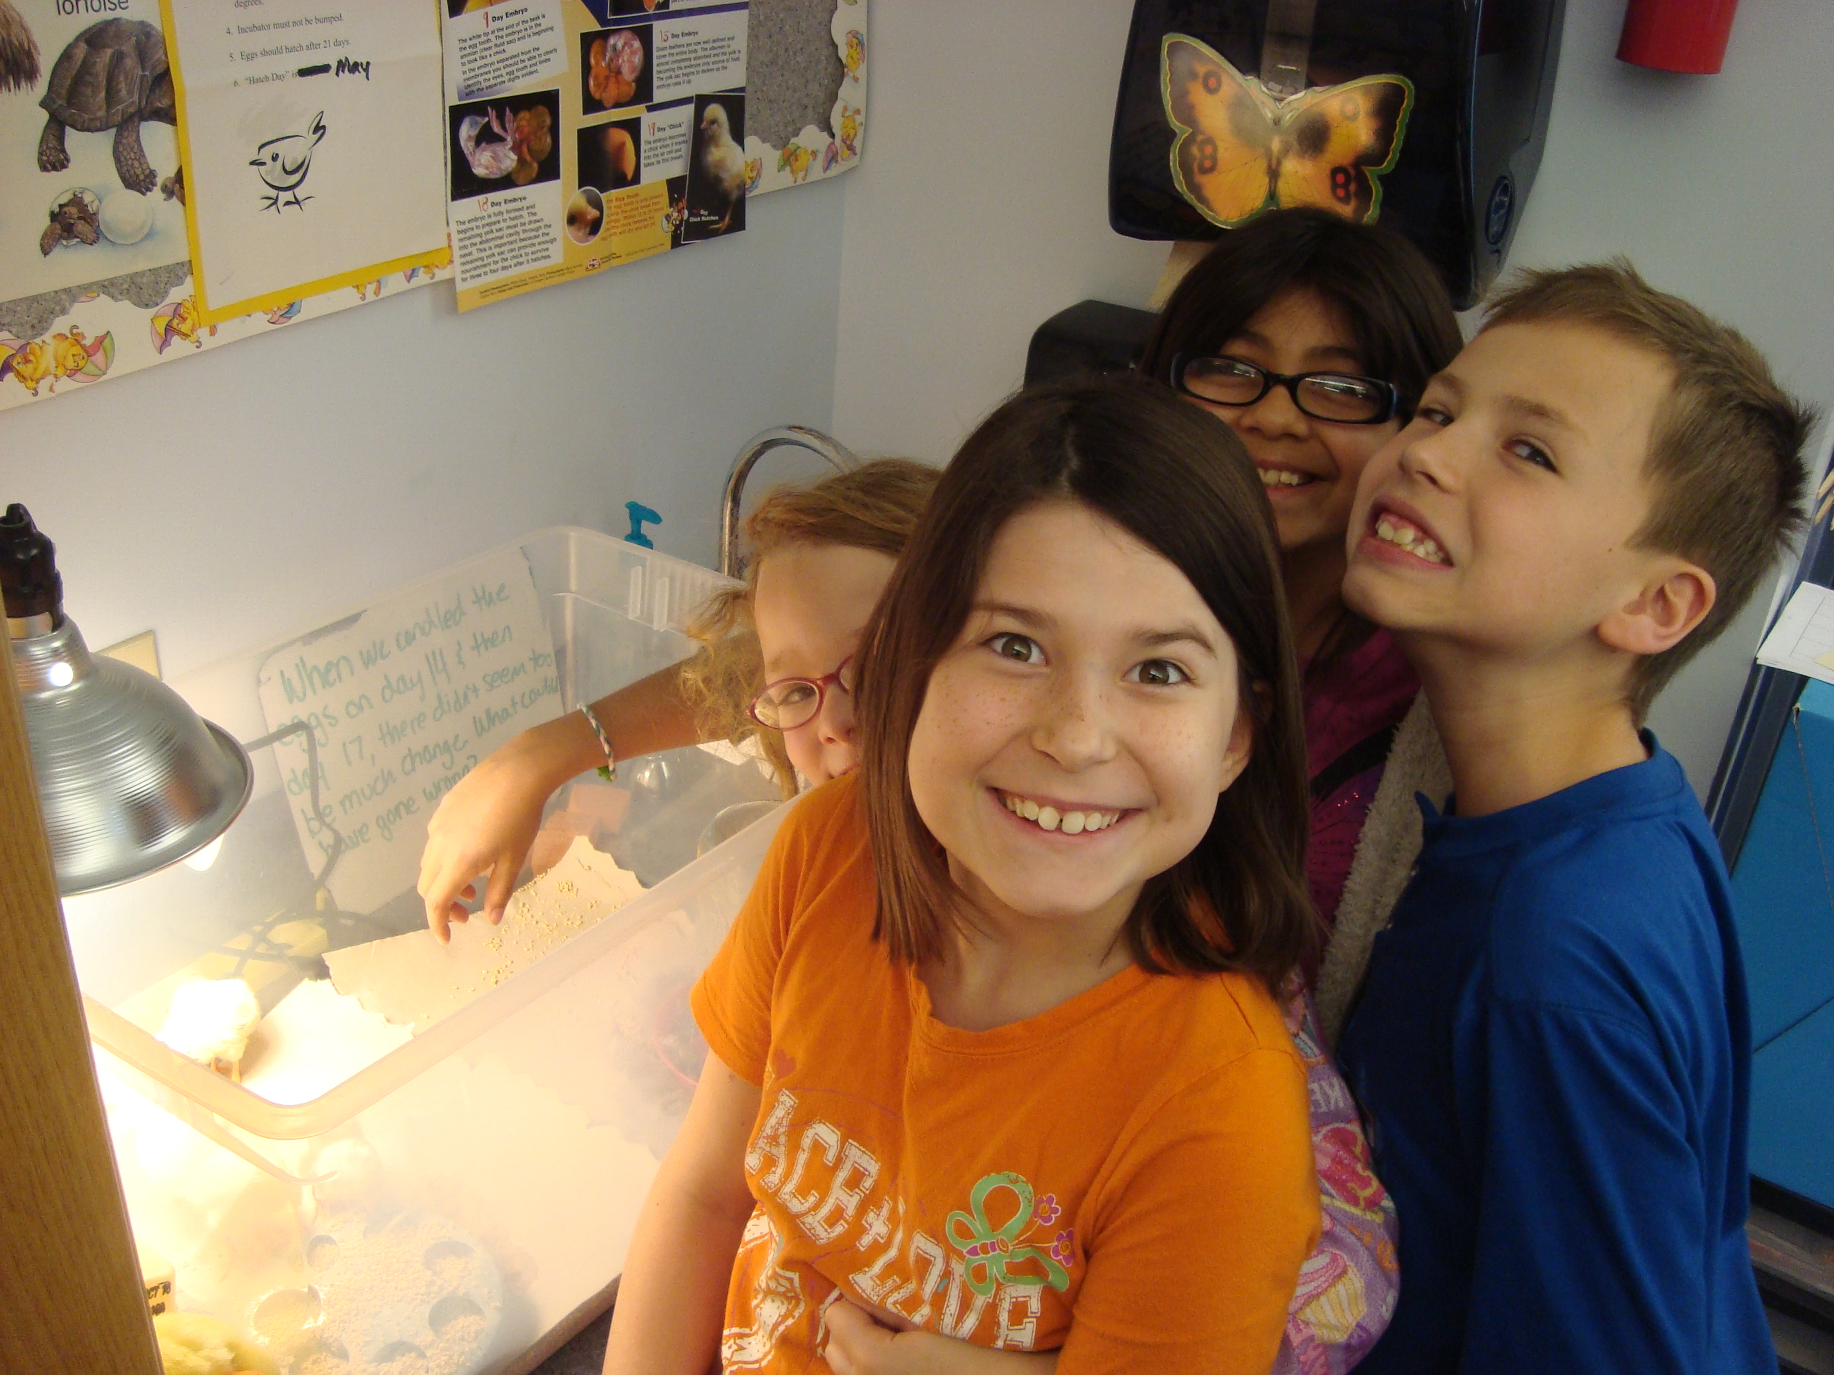

We learned so much by taking care of our eggs and then the chicks. On our day 21, we kept waiting and waiting to see and hear pecking and chirping from the chicks. Nothing happened. We were very disappointed to learn that our chicks would not be hatching. We did learn a lot about compassion though. Anita, the lady that we got our eggs from, was hatching her own eggs in the office. She offered to share hers with us so that we could take care of the chicks for a few days! We were so excited when we learned this news!
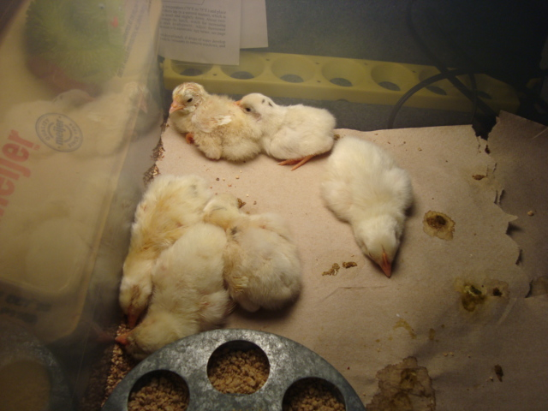

Finally, the time for Anita to arrive with the chicks came! She helped us set up the brooder box and taught us a trick: put down the kitty litter for soft bedding, then put paper towels down on top of that so it is easier to clean out the box (because chicks are very messy!). The chicks were very tired when they arrived and they fell asleep quickly!

The chicks were so cute and funny to watch. Sometimes the chicks would be running around the box flapping their wings and pecking around at the food and things. Only a little later, they would stop running and stand in one spot. Their heads would start to bend down towards the ground because they were getting tired. Their heads would bob up and down as they were starting to fall asleep like someone trying to stay awake in a boring meeting.
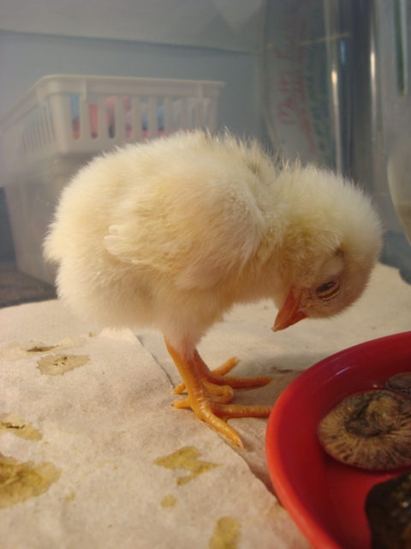

The other classes at our school wanted to see the chicks too, so we decided to have presentations for the other classes. Students kept coming through the door and filled up our classroom excited to see and pet the chicks. As we showed a video, the 3rd grade students shared what they had learned about the chicks and gave instructions about how to carefully pet them and then wash hands at the end.
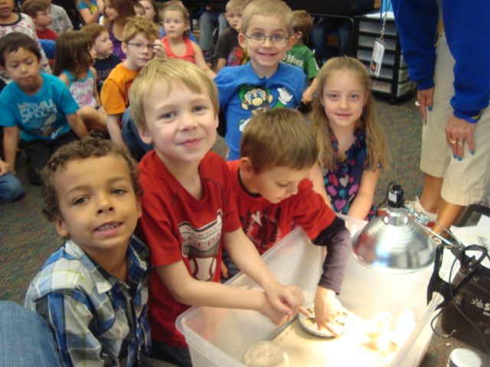
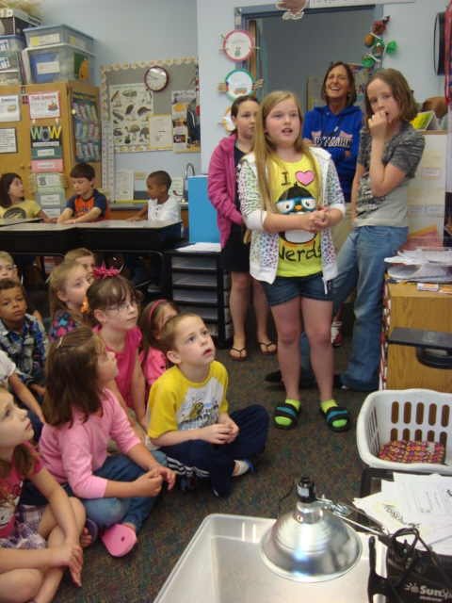
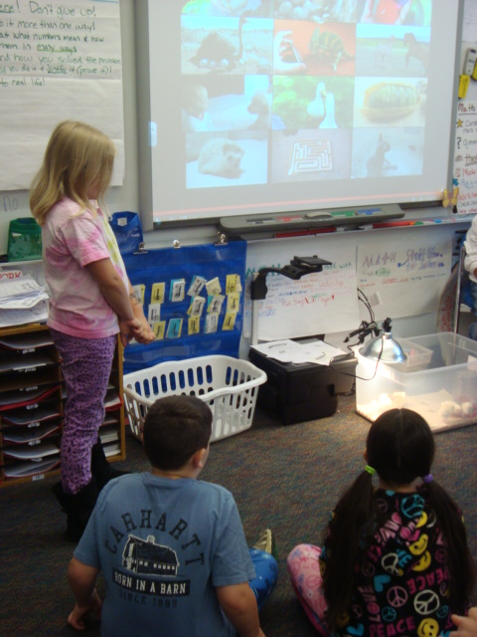

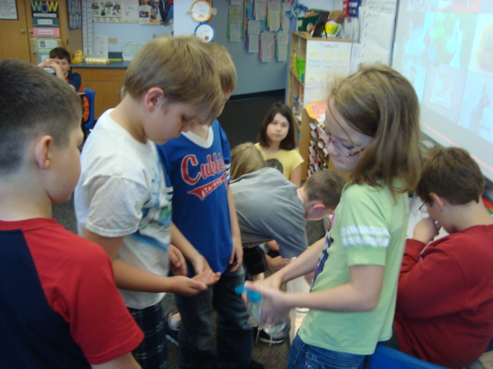
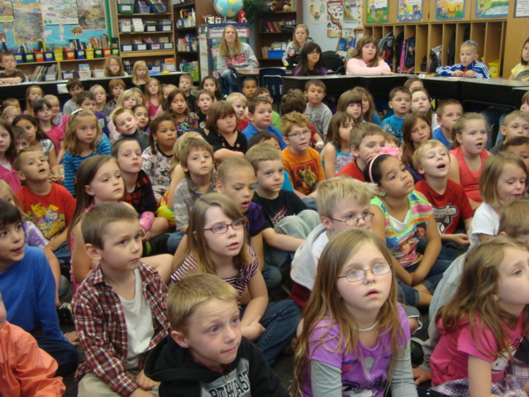

We will never forget this exciting experience with our baby chicks! We learned so much and had a blast! Thank you so much to Anita for all of her help!
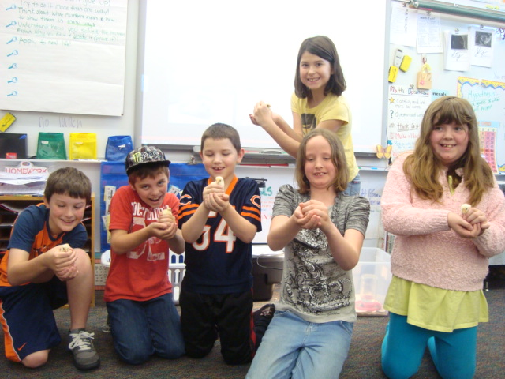

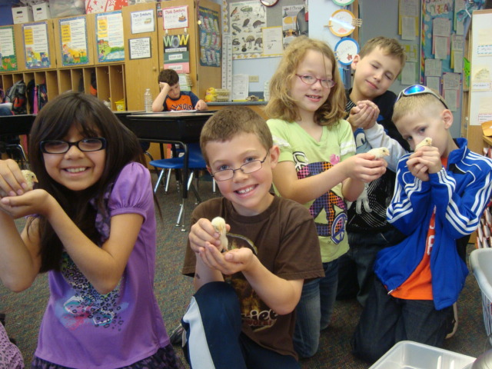

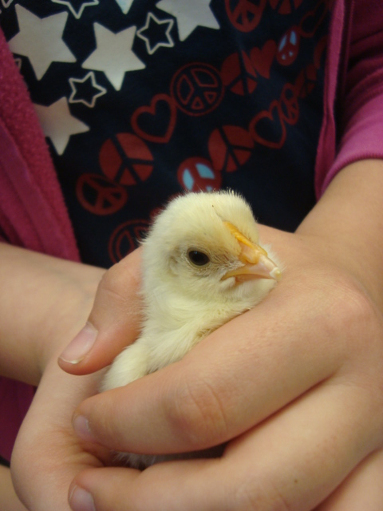

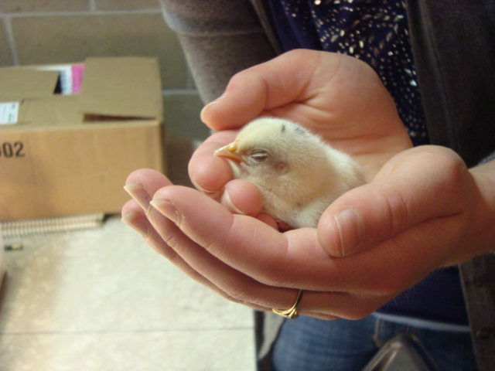
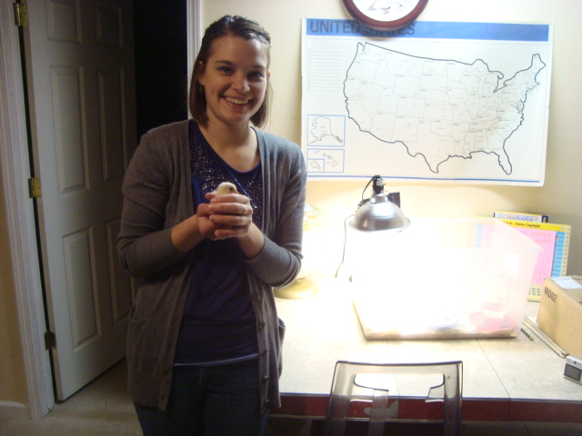

Miss Coon is a 3rd grade teacher who loves spending time with her students. Her students inspired this book when they tried to hatch chicks in her classroom for the first time in the spring of 2013. Although it did not work out, she plans to continue trying. Miss Coon enjoys reading and biking when she has free time. Some other books that she has written are: The Other Class (a realistic fiction book about recycling), and Beautiful Butterflies (a nonfiction book). She plans to continue writing more children’s nonfiction books along with her students each year.

